**Communications and Computers**

Main articles: Tracking and Data Relay Satellite and Luch (satellite)

See also: ThinkPad use in space

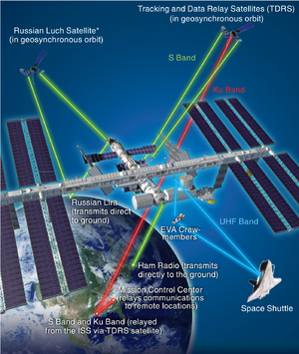

The communications systems used by the ISS  
* Luch satellite not currently in use

Radio communications provide telemetry and scientific data links between the station and Mission Control Centers. Radio links are also used during rendezvous and docking procedures and for audio and video communication between crewmembers, flight controllers and family members. As a result, the ISS is equipped with internal and external communication systems used for different purposes.

The Russian Orbital Segment communicates directly with the ground via the *Lira* antenna mounted to *Zvezda*. The *Lira* antenna also has the capability to use the *Luch* data relay satellite system. This system, used for communications with *Mir*, fell into disrepair during the 1990s, and as a result is no longer in use, although two new *Luch* satellites—*Luch*-5A and *Luch*-5B—are planned for launch in 2011 to restore the operational capability of the system. Another Russian communications system is the Voskhod-M, which enables internal telephone communications between *Zvezda*, *Zarya*, *Pirs*, *Poisk* and the USOS, and also provides a VHF radio link to ground control centers via antennas on *Zvezda'*s exterior.

The US Orbital Segment (USOS) makes use of two separate radio links mounted in the Z1 truss structure: the S band (used for audio) and Ku band (used for audio, video and data) systems. These transmissions are routed via the United States Tracking and Data Relay Satellite System (TDRSS) in geostationary orbit, which allows for almost continuous real-time communications with NASA's Mission Control Center (MCC-H) in Houston. Data channels for the Canadarm2, European *Columbus* laboratory and Japanese *Kibō* modules are routed via the S band and Ku band systems, although the European Data Relay Satellite System and a similar Japanese system will eventually complement the TDRSS in this role. Communications between modules are carried on an internal digital wireless network.

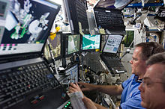

Laptop computers surround the Canadarm2 console.

UHF radio is used by astronauts and cosmonauts conducting EVAs. UHF is employed by other spacecraft that dock to or undock from the station, such as Soyuz, Progress, HTV, ATV and the Space Shuttle (except the shuttle also makes use of the S band and Ku band systems via TDRSS), to receive commands from Mission Control and ISS crewmembers. Automated spacecraft are fitted with their own communications equipment; the ATV uses a laser attached to the spacecraft and equipment attached to *Zvezda*, known as the Proximity Communications Equipment, to accurately dock to the station.

The ISS is equipped with approximately 100 IBM and Lenovo ThinkPad model A31 and T61P laptop computers. Each computer is a commercial off-the-shelf purchase which is then modified for safety and operation including updates to connectors, cooling and power to accommodate the station's 28V DC power system and weightless environment. Heat generated by the laptops doesn't rise, but stagnates surrounding the laptop, so additional forced ventilation is required. Laptops aboard the ISS are connected to the station's wireless LAN via Wi-Fi and are connected to the ground at 3 Mbit/s up and 10 Mbit/s down, comparable to home DSL connection speeds.